

Operator’s Manual

Revision 23SEP2015

CPS_r7 7.03.03

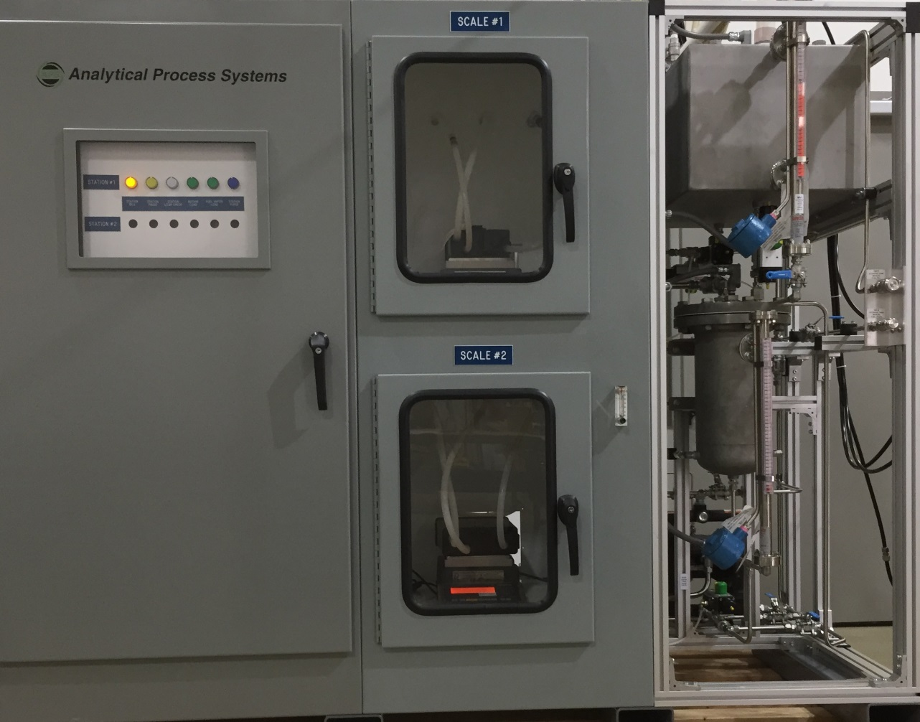

***Analytical Process Systems***

www.aps-mich.com

1771 Harmon Road

Auburn Hills, Michigan 48326

ph.(248)393-0700

**Table of Contents**

1.0 Introduction 3

2.0 Loading Test Fuel into CPS 4

3.0 System Operation 5

Startup 6

The Launch Screen……..……………………………….…………………………………………………..6

4.0 System Screens 10

Alarm Status Bar 12

Purge Air Status Bar 13

Date & Time Bar 14

Menu… 15

Tool Bar 16

Copy Files 16

Print Files 17

Canister 18

Master Recipes, Recipe Details 19

Purge by Profile, End after stable weight change.…………………………………………………………20

View - Airlog & Fuel Consumption Log…………………………………………………………………..21

Configuration……………………………………………………………………………………………....22

Leak Check 23

Load 24

Purge 25

Job 26

Process 27

System 28

Butane Available 30

Event Log 31

Job List 32

Backup Files 33

Station Detail screen in-depth 34

Job Sequences/Courses………………………………………………………………………………….....36

Overview 37

Review Data 38

Watch Data 39

MFC Calibration Screen 40

I/O Monitor Screen 41

Scale Monitor, Turn off Beacon, Silence Horn, Help.. 42

5.0 Reports / Report Generation 43

Summary Report 43

Detail Report 43

File Naming Format 44

Report Files 44

Database Files 45

Generating Reports 45

6.0 Canister Weight Monitoring 46

Single Scale with Stand Alone Canister Method 46

Single Scale with Service Port Method 47

Dual Scale Method 48

7.0 Hot Keys 49

8.0 Spare Parts and Maintenance Schedule 50

9.0 Facitilty Requirements/Specifications 51

10.0 Legal 52

**Appendix A Out of Tolerance (OOT) Determination 53**

**Appendix B Summary Data Collection 54**

**Appendix C Moisture Calculation 55**

**Appendix D Password Access Maintenance 56**

**Appendix E Terminology 57**

#### 1.0 Introduction

The Canister Preconditioning System (CPS) has been specifically developed by Analytical Process Systems to meet the requirements for evaporative emissions canister testing. Using customer-supplied butane and nitrogen cylinder gases and/or gasoline, standard and custom blended canister loading may be accomplished automatically with minimal user intervention. This makes it possible to initiate a test let Analytical Process Systems’ CPS software program perform load and/or purge testing on a variety of in-use and development canisters.

The CPS provides up to nine stations and four shifts for the Purging and Loading of activated carbon canisters. The CPS monitors the operating status of all stations and generates reports whenever a task is run. Reports are stored locally on the system computer and may also be transferred to a host system for archiving. When the network option is selected, database and report files are stored locally on the system computer and, if specified, on the network directory.

#### 2.0 Loading Test Fuel into Canister Preconditioning System

The APS Canister Preconditioning System with Live Fuel and/or Butane loading capabilities, utilizes (2) stainless steel fuel storage tanks which hold the test fuel used during fuel vapor loads. The upper storage tank holds approximately 35 gallons of fuel (plus head space), and the vapor generator tank holds approximately 4 gallons. During live fuel vapor generation, the vapor tank is filled from the above storage tank to approximately 2 gallons, allowing for head space. A combination of level indicators and level switches, wired through appropriate Intrinsic Safety Barriers, allow safe and automatic fuel tank level management under control of the CPS computer. Additionally, manual draining and filling is available to the operator via several hand valves which area clearly labelled.

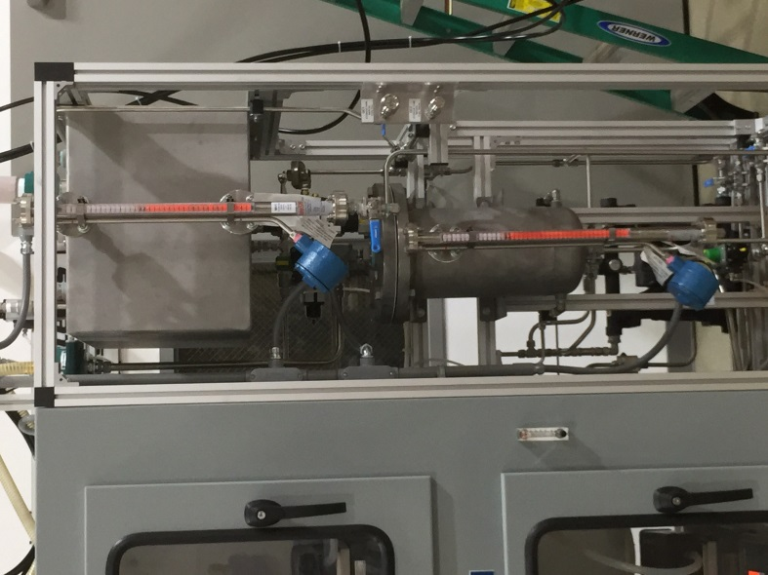

Vapor Tank

Level

Fuel Vapor

Generator Tank

Fuel Storage

Tank

Storage Tank

Level

Tank

**Please ensure all fuel containing vessels are properly grounded to prevent static discharge during fuel transfer operations.**

#### 3.0 System Operation

The system consists of a desktop computer that continuously monitors activity on the Canister Preconditioning System and automatically generates reports of that activity. Reports are stored locally on the CPS’s computer and may be manually or automatically sent to a local or network printer. Test reports may also be transferred to a host computer for analysis, long-term storage, and archiving. The system generates four types of reports for each process that has completed: a *Detail Report*, a *Summary Report*, a Microsoft Access® Database File, and an Excel report file. Additional reports are also available. These include recipes, system configuration, and alarm logs. The operator interface is keyboard and mouse. The menus follow the traditional Windows format, starting with a *Main Menu* on the *System Overview* screen, with sub- menus which allow access to particular functions. The *System Overview* screen provides a summary display of all activity on the system. *Detail Screens* for each station provide all operational information for the station and allow entry of test related data that is printed on all reports. This data includes items such as the vehicle number, engineer, canister information, technician, along with test comments. Additional operations include copying and printing reports, modification of tolerances and configurations for reports, viewing of recipes, viewing of the job list and other logs. Several of the operations available on the system are password protected to prevent use by unauthorized personnel. Items such as hardware configuration, setting of tolerances and exiting the software are functions restricted to users with sufficient password level.

** DO NOT** use the equipment in a manner not specified by the component manufacturer or Analytical Process Systems.

###### Startup



**The Windows desktop. Actual background image may vary.**

**The Launch Screen**

Launch the CPS_r7 application by double-clicking on the desktop icon. A software launch screen will appear, as shown below:

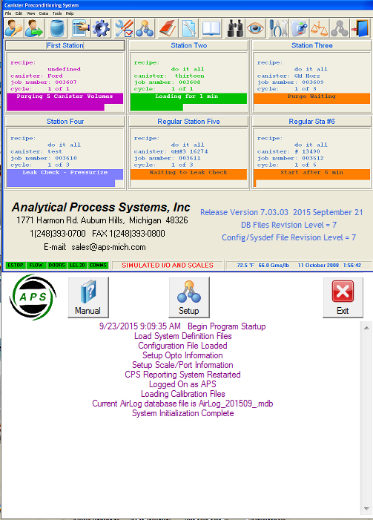

**CPS Launchscreen**

The launch screen shows the software version number, and other pertinent information. It is also possible to open the Operator’s Manual from the launch screen.

Once the program has loaded, the user will be viewing the Canister Preconditioning System Overview screen.

Station Detail button

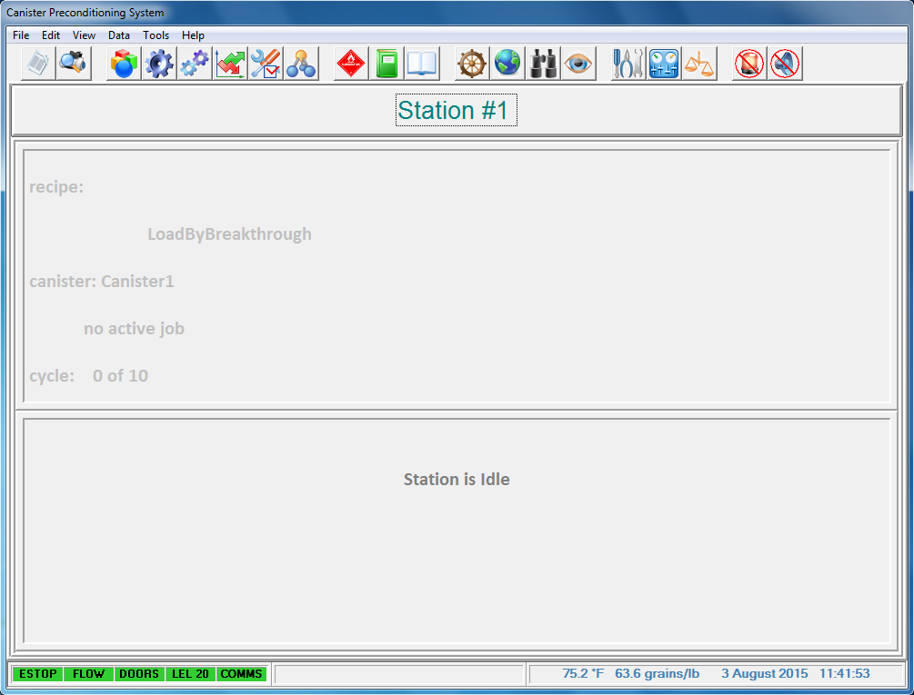

**Overview screen**

To start a test, click the Station Detail icon, which looks like a ship’s wheel . The Station Detail screen appears:

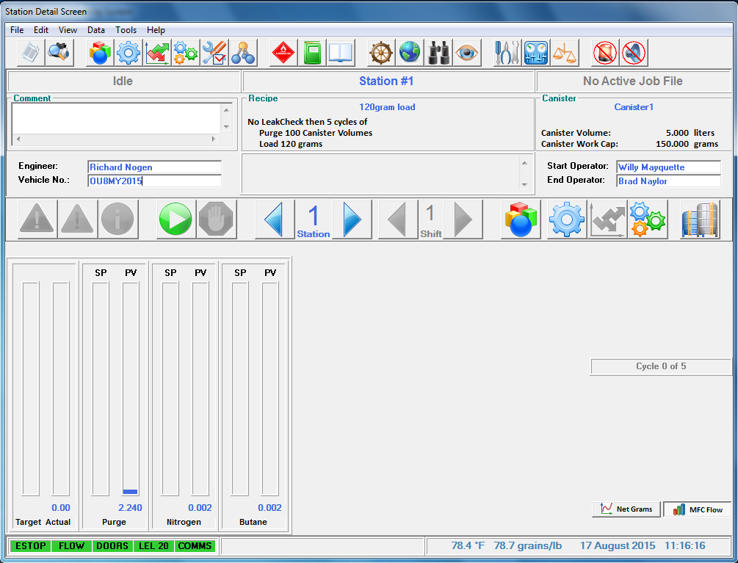

**Station Detail Screen**

Next, click on the green Start Job arrow  , or click on the Recipe icon  to select or edit the station recipe.

The following is an *example of a typical test sequence* on the Canister Preconditioning System. This example is intended to illustrate the operation and features of the System and is not intended to specify operating procedures that must be followed.

1. **Connect the Canister**

Connect the canister to the desired Station ensuring connections are made to the proper ports. (Load, Purge, and Vent*) NOTE:* APS recommends using an inline filter on purge port of canister to prevent carbon from entering the system.

1. **Check Auxiliary Scale and #, if Using It. (load by breakthrough)**

If the process involves use of the auxiliary canister, verify proper connections to the auxiliary canister. (Scale: Load Port / Station: Aux Load Port)

1. **Check Primary Scale and #, if Using It**

If the process involves use of the primary scale, verify proper connections to the canister. (Scale: Load Port, Purge Port, and Vent Port / Station: Load Port, Purge Port, and Vent Port)

1. **Start the Process – Station/Shift**

Select Canister and modify the Working Capacity and Volume, if required.

Select Process Recipe on the screen. Modify the recipe as needed.

1. **Canister System Starts Process**

The System will activate when the green Start Job button is pressed and will then begin logging data for the selected station. The system will perform the following operations at the start of the process:

1. Assign the next sequential report filename to the process.
2. Create a database file for the process.
3. Record the process Start Time and Recipe Information.
4. Create an entry in the Job List for the current process.
5. Activate the Status Indicator on the Main Screen to indicate the current mode of the Process.
6. Indicate scale reading.
7. **Activate Thermocouple Data Logging (optional feature)**

If the process is being performed on a station, and it is desired to log the thermocouple values to the reports, activate the Thermocouple Logging from the Station Detail Screen. Thermocouple logging is defaulted off each time a new process starts.

**System monitors activity throughout Purge and Load**

During the process, the canister system performs the following functions:

1. Logs Purge and Load data into database at the intervals of one to five seconds based on the time value from the configuration settings.
2. Records Maximum, Minimum and Average Values of Flow and Ambient Conditions for Summary Screen and Summary Report.
3. Monitors Flow and Ambient Conditions for out of tolerance events, logging any events to the station logs. (Tolerance limits are specified in System Configuration)
4. Monitors system for Cabinet Exhaust Flow, Door Switches, Gas Detection, Emergency Stop or other alarm conditions.
5. **Enter Operational Data on Station Detail Screen**

From the time the Process begins, until the process completes ***and*** returns to the IDLE mode, the Station Detail Screen allows the operator to enter operational data and remarks for the current process. Entry of this data is not required for proper operation and reporting, however it may be required to ensure proper documentation of all processes. Data that can be entered includes:

|  |  |
| --- | --- |
| 1. Engineer | 1. Start Operator |
| 1. Vehicle Number | 1. End Operator |
| 1. Canister Identifier | 1. Comments |

1. **View Station Status on Detail Screen**

Whenever a process is active on a station, the Detail Screen provides complete details of all activity. The screen provides the following information:

1. Current Operating Mode (Idle, Leak Check, Purge, Load, Pause, etc.)
2. Mass Flow Controller Target and Actual Flow Rates
3. Scale(s) in use and scale reading(s)
4. Current Cycle Number
5. Process Target and Actual readings
6. Thermocouple Temperatures (Optional)
7. Alarm Status Bar
8. Operational Data entered by Operator
9. Access to Recipe Button for display of current Recipe
10. Access to Summary Button for display of current Summary Statistics
11. Access to Alarm Button for Display of Alarm Log
12. Access to Tolerance Button for Display of any Out of Tolerance Conditions
13. Access to Thermocouples On Button to activate logging of TC values (Optional)
14. Stop Button to abort the process
15. Current data base file being used
16. Current temperature, absolute humidity, date, and time
17. **Process Completes**

When the process for a station completes, the system will generate the process reports via Report Generator application. If the automatic print option is selected, the system will send the current station process Summary and/or Detail report(s) to the selected printer. The system also updates the Job List for the current process and then goes into IDLE mode. If the station has another shift or shifts (optional feature) waiting in queue, the next shift then will start the process automatically.

**Concordance**

During a butane load, the following Concordance screen is displayed:

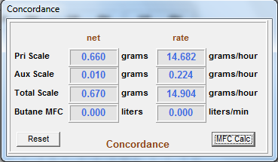

Concordance is a mathematical “cross check” against the weight gain of the scale at a given load rate.

Concordance cannot be computed in the case of a fuel vapor load. Thus, the Concordance screen does not appear in any live fuel test.

#### 4.0 System Screens

When the software is launched, after a brief system check and initialization, the System Overview Screen will appear on the computer. The System Overview Screen provides a summary display of the status of all stations and alarms. All the major components of the system can be accessed from the Menu Bar which is located along the top of this screen or the Tool Bar which is located underneath the Menu Bar.

Menu Bar

Tool Bar



**Overview Screen**

Date & Time Bar

Purge Air Status Bar

*Humidity displayed as* ***Grns/lb*** *or* ***% rH***

Alarm Status Bar

|  |  |  |
| --- | --- | --- |
| Alarm Status Bar The Alarm Status Bar displays the condition of Alarms on the Butane Loader. Green indicates the normal operating condition, Yellow is for warning, and Red indicates the Alarm condition is active.  *The following conditions are monitored:*  E-stop Emergency Stop  Flow Cabinet Exhaust Flow Switch  Doors Cabinet Door Switches (optional)  LEL-20 HC Vapor Concentration Alarm, 20 Percent LEL  Comms PC Communications Status | |  |
| Purge Air Status Bar |  | |
|  |  | |

The Canister Preconditioning System monitors the ambient Temperature and Moisture level in the area of the system installed. If the Purge Air System (PAS) option is installed, both temperature and moisture readings are obtained from the PAS directly. Depending upon the system definition settings used, humidity will used displayed in either grains/lb or % rH units. These conditions are read when any station is in the Purge Mode to determine if Purge Air conditions are within desired tolerance. Current values are displayed on both the Overview Screen and the station Detail Screen.

Absolute Moisture is provided in grains per pound (or % rH if desired), the units used by the EPA and CARB to specify the moisture conditions required. The Absolute Moisture level is calculated using temperature, relative humidity and barometric pressure, see Appendix C for the actual calculation formula. The current values of temperature, relative humidity and barometric pressure are displayed on the Common I/O Monitor screen.

###### 

###### Date & Time Bar

The Date & Time Bar shows the currently date and time of the computer’s real-time clock.

###### Menu Bar

The Menu Bar consists of the following menus:

File

Edit

View: AirLog., Butane Available., Event Log., File Maintenance Log., Fuel Consumption Log., JobList

Data

Tools

Help: About CPS release7 will open the following window, which contains system information such as the software version:

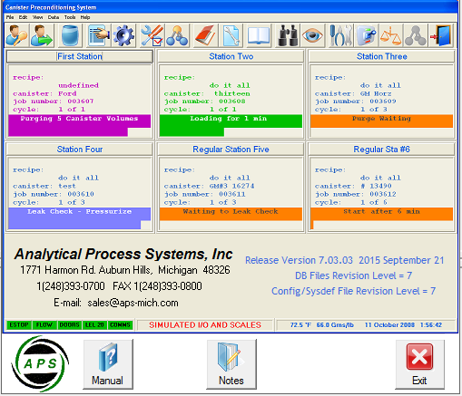

**To exit the program, the operator has to select the Exit icon from the Exit Program function in the File menu under the Menu Bar or in the window below:**

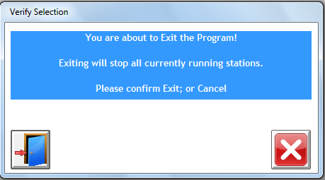

**Exit Program window**

###### Tool Bar

Copy Files

Copy document

Use this icon to copy reports or other files from one location to another.

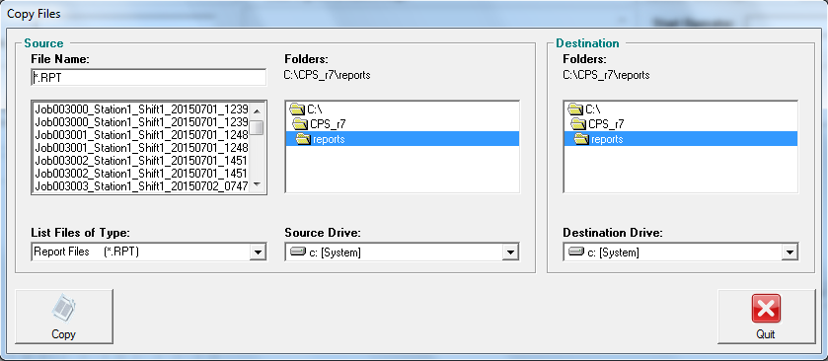

**Copy**

copy file(s) from source directory to destination directory

**Quit**

exit the copy files routine

Print Files

Print preview

Use this icon to send files to printer or display files on the computer screen.

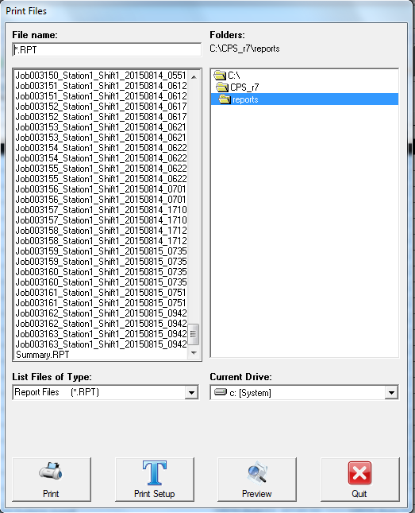

**Print**

Sends files to the default printer

**Print Setup**

View/modify how printout appears on paper

**Preview**

Displays files on the computer screen before printing

**Quit**  Exit

Canister

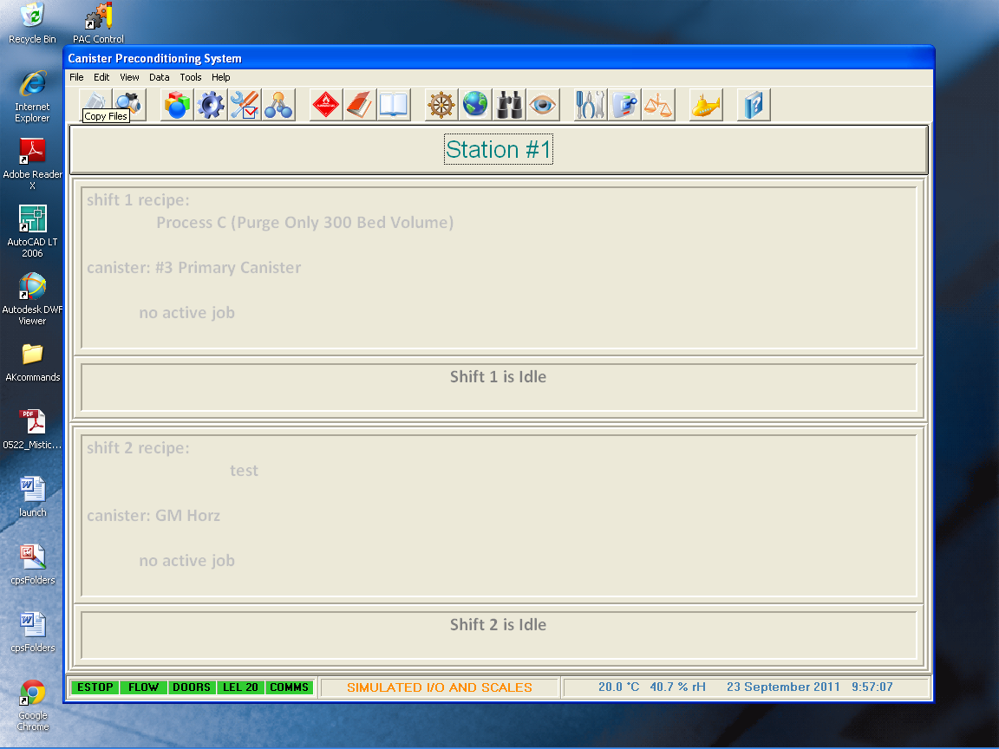

Use this icon to view and modify the working capacity and volume of pre-saved canisters.

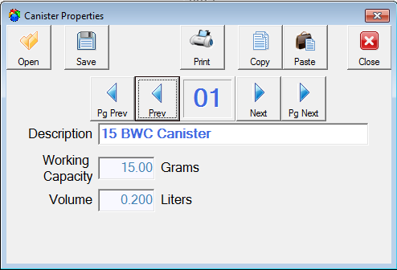

Master Recipes



Use this icon to view and modify the master recipes. Master recipes become

the basis from which Station Detail recipes are built.

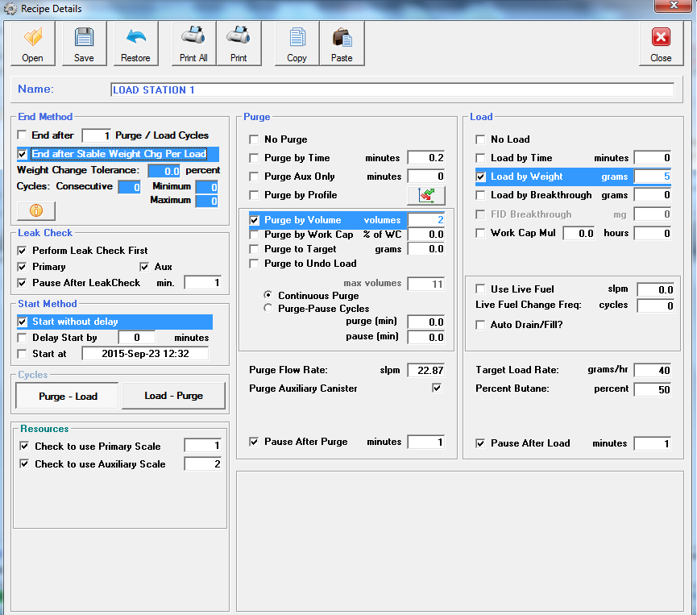

**Station Recipe Details screen**

On the Recipe Details screen, the user may set typical parameters for each phase of the canister tests – Cycle, Purge, and Load parameters, allowing maximum testing flexibility. Once changes have been made satisfactorily, clicking Save will store the settings to the Master Recipe database. When loaded as a Station Recipe, user selections are validity against the hardware present. Invalid entries will be highlighted in yellow. When all entries are correct, a message appears containing an estimate of the time required to execute the user’s test. The green Run arrow is then available.

** Purge by Profile:** This CPS feature allows the user to purge a canister using a custom profile of the desired purge rate vs. time. See below:

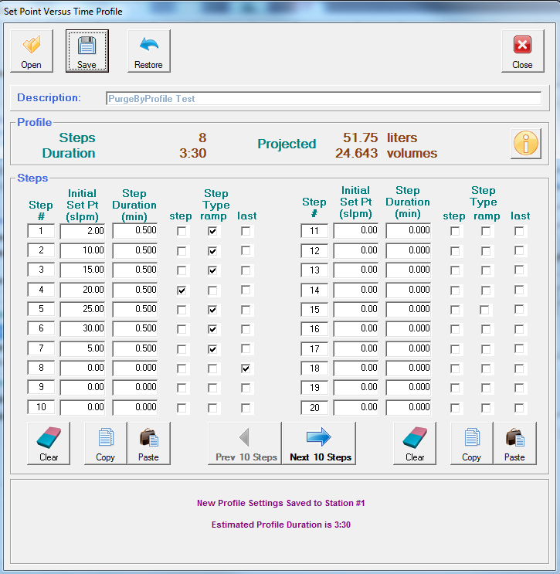

The user enters a series of steps, indicating each step’s flow rate, duration, and step transition mode. Clicking Save button validates the profile, and estimate of Profile Duration is displayed.

**End after stable Weight Chg Per Cycle:** when checked, the cycle-to-cycle load stability (within the specified weight tolerance, in grams) is established, based on the number of consecutive readings, minimum number of cycles, and maximum number of cycles. During a test using *End after Stable Weight Change Per Cycle*, the following window will appear during Load cycle:

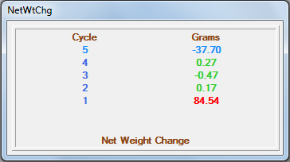 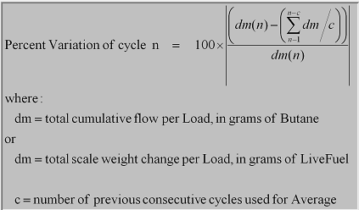

**Color code**

Blue: changing value given during a *running* load cycle

**Red:** value is outside of stability criterion

**Green:** value is within stability criterion

View - AirLog

To view a graph of facility’s air supply conditions-(temperature, moisture, humidity), select View, AirLog from the menu bar. The current AirLog database will open. Next, click on Display Chart button to display the AirLog graph. Maximum length of AirLog database is one calendar month. Similarly, the user may view a summary of fuel vapor and/or butane used in the system, on a month-by-month basis. See images below:

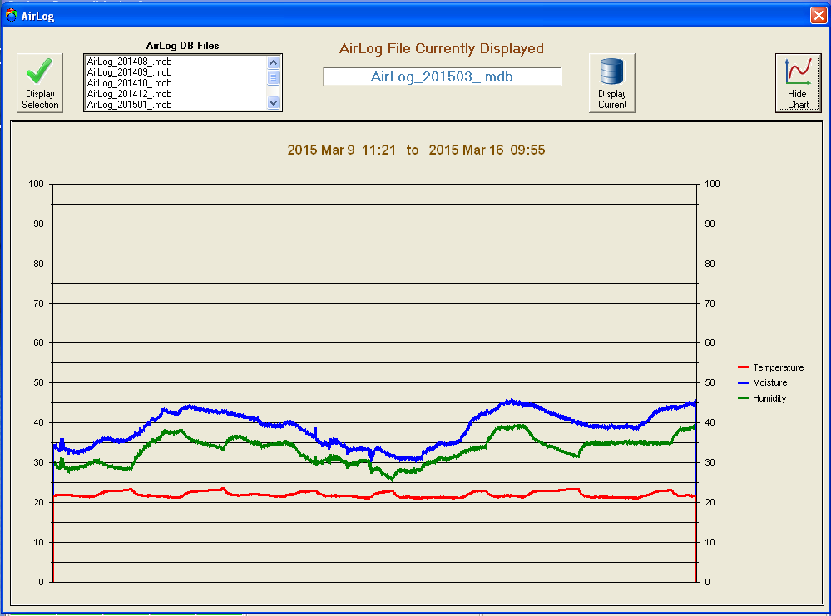

**AirLog environmental graph**

View – Fuel Consumption Log

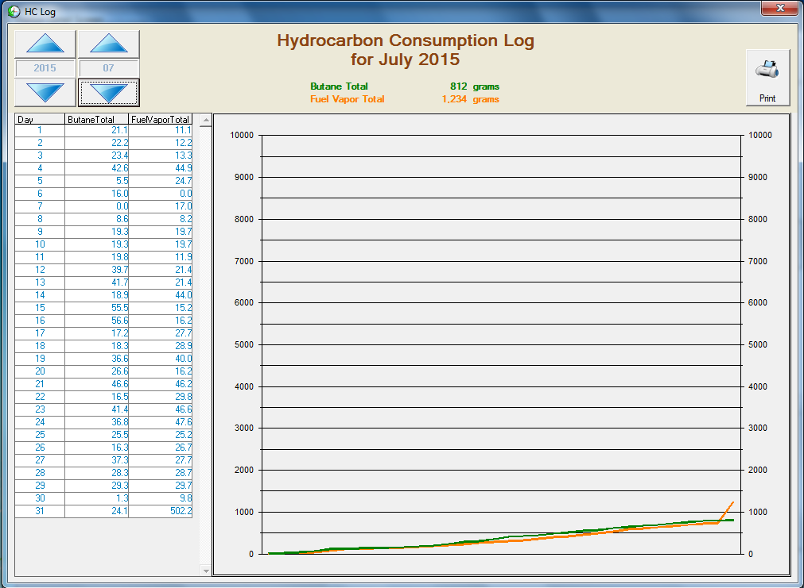

**Fuel consumption graph**

Configuration Screen

Check options

Configuration values may be viewed by any user, however proper access levels are required to edit and save the values.

When saved, configuration values are stored on the hard disk. Saved values are reloaded each time the CPS system is restarted or when the Load operation is selected from the Configuration Screen.

Tolerances specified in the System Configuration are used by the system to determine when a flow, temperature, humidity or process total variable is out of tolerance. Out of tolerance occurrences are noted on all of the reports. The Summary Report also uses these values to summarize the overall process.

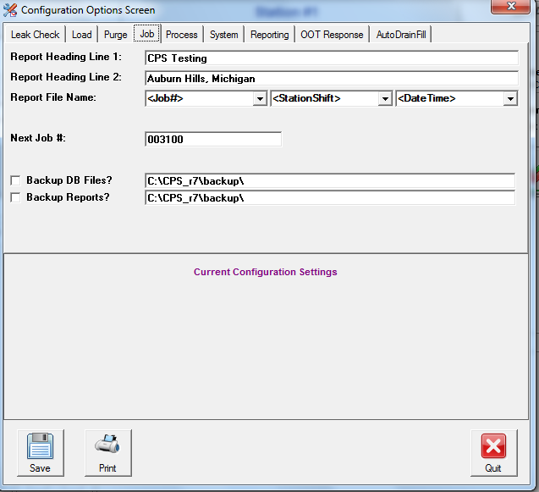

The Configuration Screen consists of the following sub-menus:

**Leak Check**

**Load**

**Purge**

**Job**

**Process**

**System**

**Reporting**

**OOT Response**

**AutoDrainFill**

Leak Check

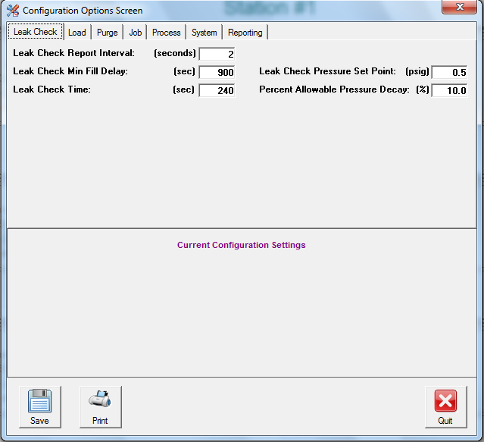

**Leak Check Report Interval (Seconds)**

Specifies the time for the detail report interval.

**Leak Check Min Fill Delay (Seconds)**

Specifies the time for the stations to achieve the required pressure during the leak check.

**Leak Check Time (Seconds)**

Specifies the time for the stations to maintain the pressure (Leak Check Pressure Set Point), applicable with pressure decay (% Allowable Pressure Decay) factor.

**Leak Check Pressure Set Point (PSI)**

Specifies the desired leak check pressure.

**Percent Allowable Pressure Decay (%)**

Specifies the percentage of pressure decay allowable within the leak check time specified.

Load

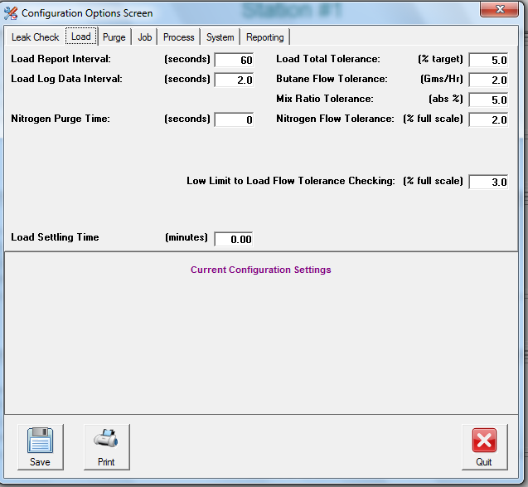

**Load Report Interval (seconds)**

Specifies the update interval for the Detail Report during Load cycles.

**Load Log Data Interval (seconds)**

Specifies the update interval for the Database file during Load cycles.

**Nitrogen Purge Time (seconds)**

Time for N2 pre-flow prior to each Load cycle.

**Load Total Tolerance (% target)**

Specifies the tolerance for the Load Cycle total, with relation to the target. The value represented by the Load Cycle target may vary, depending upon the Load method selected. (i.e., it could represent total butane, or could represent total time)

**Butane Flow Tolerance: (grams/Hr)**

Specifies the allowable flow rate tolerance for the Butane Mass Flow Controller.

**Mix Ratio Tolerance (abs %)**

The Canister Preconditioning System monitors the ratio of Butane to Nitrogen in % Butane. This tolerance represents the tolerance for the mix ratio.

**Nitrogen Flow Tolerance (% full scale)**

Specifies the allowable flow rate tolerance for the Nitrogen Mass Flow Controller.

**Low Limit to Load Flow Tolerance Checking (% full scale)**

This value specifies the low limit for the Purge Flow checking. Load Flow values below this setting are truncated to zero to prevent system noise.

**Load Settling Time**

Time after completion of cycle before readings are taken from scale(s).

*Note that the Maximum and Minimum values provided in the summary report are continuously updated, and are not affected.*

Purge

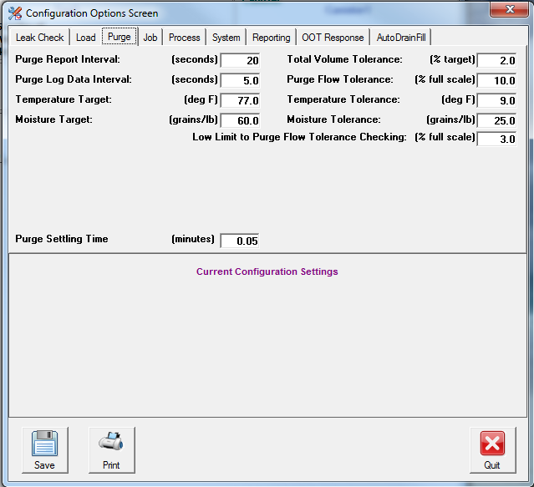

**Purge Report Interval (seconds)**

Specifies the update interval for the Detail Report during Purge Cycles.

**Purge Log Data Interval (seconds)**

Specifies the update interval for the Database file during Load cycles.

**Purge Flow Tolerance (% full scale)**

This value is the tolerance for the Purge Air Flow Control.

**Total Volume Tolerance (% target)**

This value specifies the tolerance for the total Purge Process. The actual total volume flowed is compared to the Target and must be within this tolerance.

**Temperature Target (degrees F or C) Temperature Tolerance (degrees F or C)**

**Moisture Target (Grns/lb or % rH) Moisture Tolerance (Grns/lb or % rH)**

These values indicate the target and tolerance values for the Purge Air. The system only monitors Purge Air for an Out Of Tolerance condition when the station is actually performing a purge operation.

**Low Limit to Purge Flow Tolerance Checking (% full scale)**

This value specifies the low limit for the Purge Flow checking. Purge Flow values below this setting are truncated to zero to prevent system noise.

**Job**

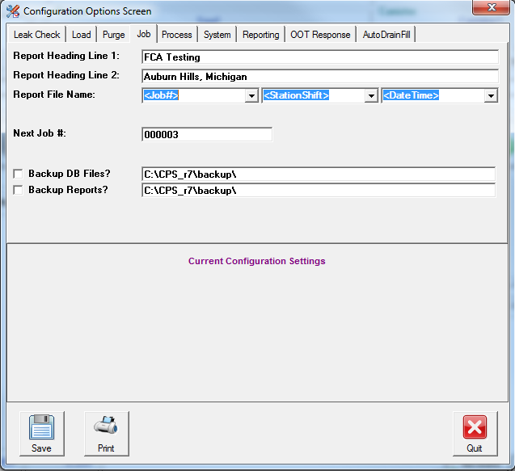

**Report Heading Line 1, Report Heading Line 2**

These heading entries permit the user to enter custom headings that are printed on the reports.

**Report File Name**

These fields allow user to customize the format of the file names to be used for the reports.

**Auto Print Setting**

Select this option for the automatic printing of report at the end of the test.

**Next Job #**

Enter the next job/report sequence number to be used. The system will increment this field by 1 for each new job.

**Backup DB Files, Backup Reports**

Check these fields and specify the locations if duplicate copies of the database files and/or reports are desired.

Process

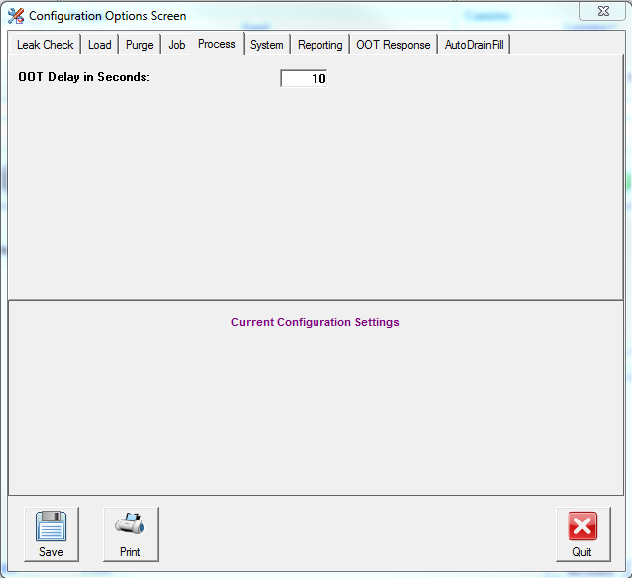

OOT Delay in Seconds

This setting specifies the time duration required for the Purge or Load MFC flow rate which is continuously beyond the tolerance setting to trigger the out of tolerance condition.

System

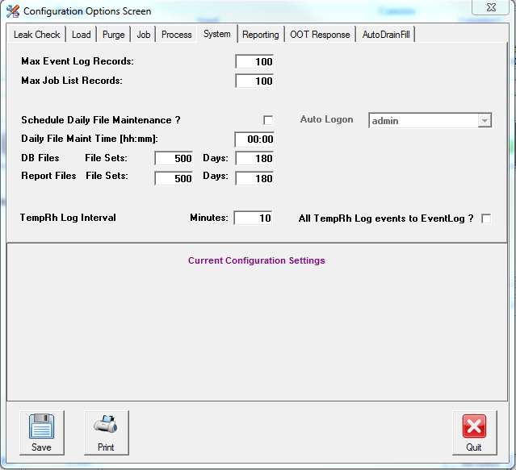

The **System** tab is used for the management of test database files. *Note: The hard drives in today’s PCs are sufficiently large so that daily file maintenance isn’t necessary. This feature is provided in the event it is needed by the user.*

**Reporting**

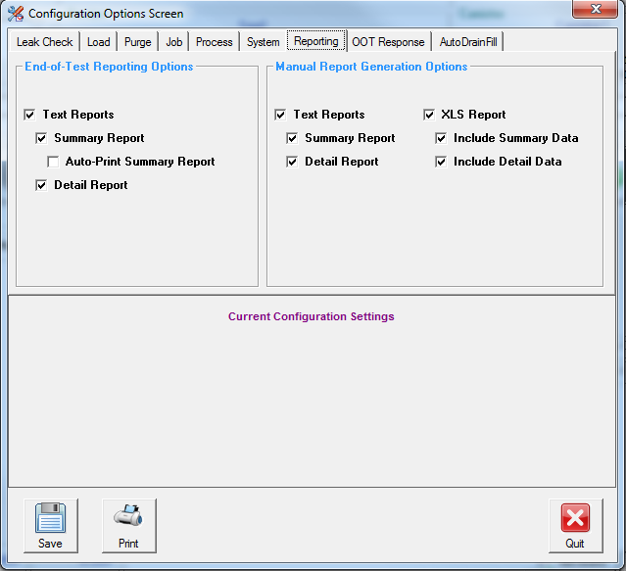

**End-of-Test Reporting Options**

When checked, these reports will be generated automatically by the CPS system’s computer, and be placed in the c:\cps_R5\reports folder. Manual reports are initiated by the user after the completion of a test, and may only be run while the CPS system is idle.

**OOT Response**

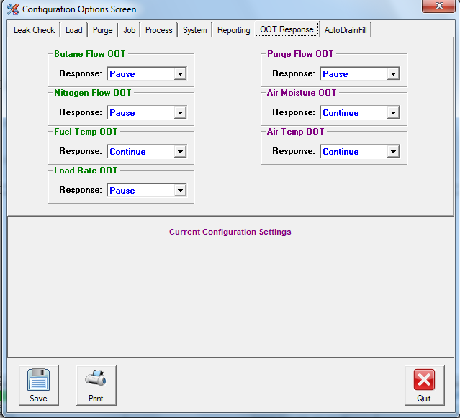

**OOT Response**

Controls the manner in which the system responds to the various Out-of-Tolerance conditions. Three responses are possible: Pause, Continue, or STOP. If set to Pause, the corresponding OOT condition will cause the system to halt, awaiting the user to press Continue. If set to STOP, the system will conclude the currently running test, generate reports, then exit the program upon encountering the selected OOT condition. Setting to Continue causes the system to continue to execute, while capturing the OOT in the system’s Out-of-Tolernace log.

**Auto Drain Fill**

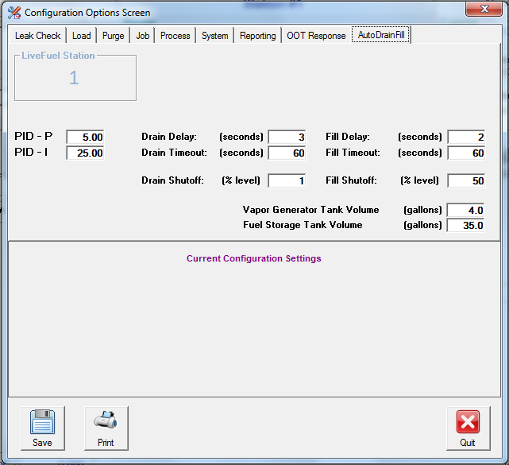

**Auto Drain Fill** allows the system user to setup the Storage and Vapor tank parameters,

such as PID algorithm P and I(used to adjust vapor loading rate)., Drain and Fill settings for both the storage and vapor tank, as well as tank volumes.

**Butane Available**



Use this icon to view or reset the calculated butane supply level. This is an estimate of butane availability based on the MFC totalizing algorithm in the software and is not a direct measurement of gas remaining in the cylinder.

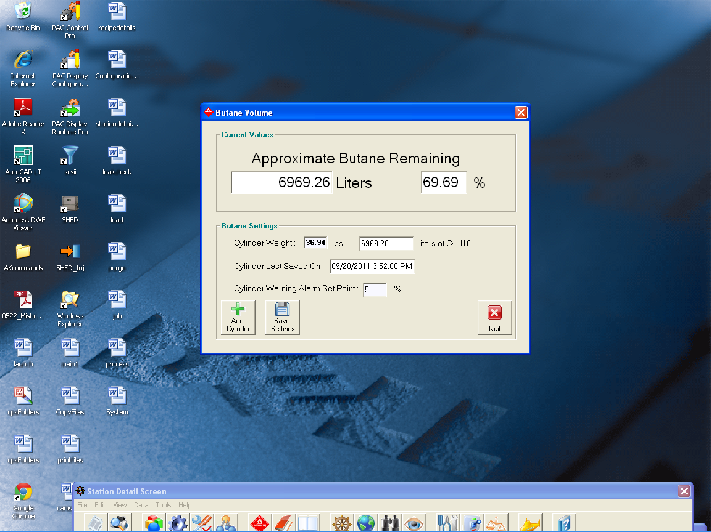

**Cylinder Weight**

Enter nominal weight of butane cylinder. Available butane is automatically calculated and displayed in Liters of C4H10 field. Approximate Butane Remaining is also calculated and displayed. Falling below the low limit threshold will generate a “Low Butane Warning” message, and is logged as a system event.

**Add Cylinder**

Used when replacing butane cylinder. User enters weight of new cylinder, system sets as 100% full.

**Save Settings**

Save the current butane cylinder settings.

**Quit**

Exit the Butane Available routine.

Event Log

Case history

Use this icon to view system events which have occurred, such Butane Cylinder Changed, or CPS Reporting System Restarted.

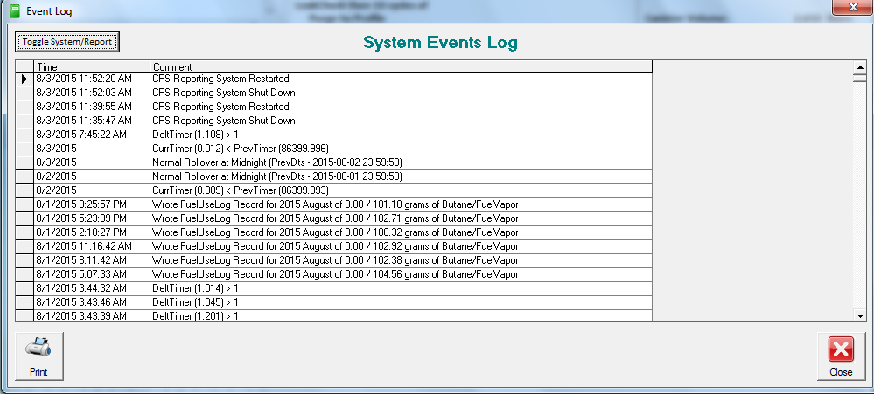

List of Jobs

Book of record

The Job List provides the following information for each process:

Job Number, Job Description, Vehicle Info, Start Time, Stop Time, Station and Shift, and Report File Name.

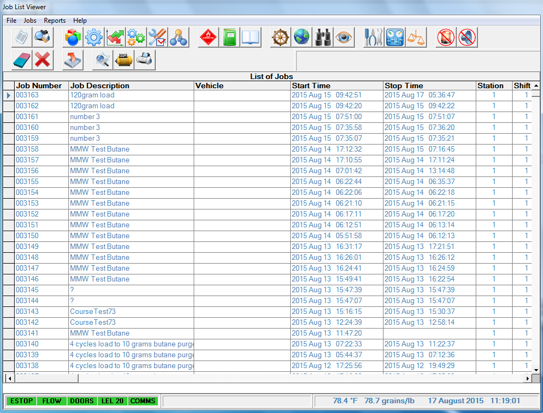

**Clear Job List**

Eraser

This function will clear the job list (data base for the job in NOT deleted).

**Delete the Selected Job**

Erase

This function deletes the job information selected by operator (the data base file for the job is NOT deleted).

**Backup Files**

Upload

This function will backup report/database files to location specified in the job configuration screen.

**Preview Reports**

**Preview**

Use this function to view reports in Notepad for the selected job.

**Generated Reports**

**Reports**

Use this function to generate reports from the existing database file.

**Print Reports**

**Print**

Use this function to print summary and/or detail reports.

Station Detail Screen

Steering-wheel

Use this icon to access the screen for monitoring the specific station.

Operating Status Box



Operating Status Box

The Operating Status Box displays the status of the station with the following modes:

**Idle** Station Available for Use

**Leak Check** Leak Check in progress

**Waiting Leak Check** Process started, Station waiting for Leak Check

to become available. Only one leak check is allowed

at a time.

**Waiting For Oper** During a Sequences test., the user has selected a Pause course. Press the green ‘run to continue’ button.

to become available.

**Waiting Purge**  Process started, Station waiting for Purge to

become available. To reduce the HC concentration

in the ventilation system, a minimum of 5-minute elapse time is required for a second station purge to start.

**Purging** Purge Process Active

**Loading**  Loading Process Active

**Paused**  Paused, After Purge or Load

**Purge Delay**  Operator Specified Wait Time after Leak Check

**Load Delay** Operator Specified Wait Time after Purge

Job Sequences/Courses



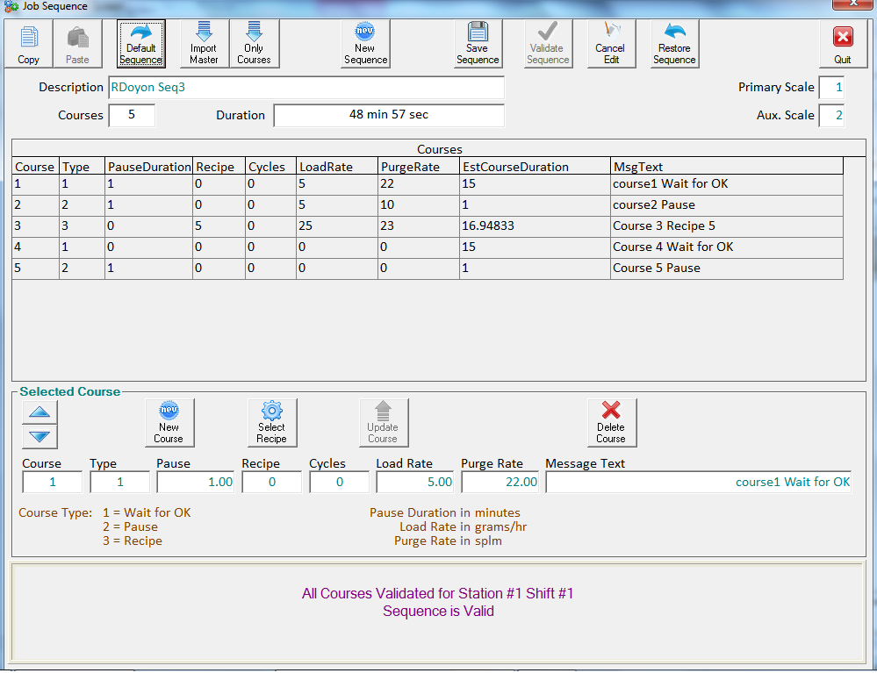

Using the Canister Preconditioning System’s Job Sequences feature, it is possible to simulate a real-world drive cycle’s effect on a canister. This could be accomplished by assembling a sequence of purges and loads of varying duration as in a park and commute scenario. In Job Sequences, the user builds one or more “Courses” using the Job Sequences editor. In the example test sequence: Course 1 = Wait for OK., Course 2 = Pause., Course 3 = Recipe 5., Cycle 4 = Wait for OK., Course 5 = Pause. After it is built, pressing Validate Sequence causes the system to check the desired Sequence against the existing station hardware. Additionally, each an estimate of the time required to execute each course, along with the Sequences total time estimate, is computed. Once validity is established, pressing Save Sequence sends the Job Sequence to the canister station, where it may be executed.

Overview



This is the main system screen which is displayed by default when the system is first started.

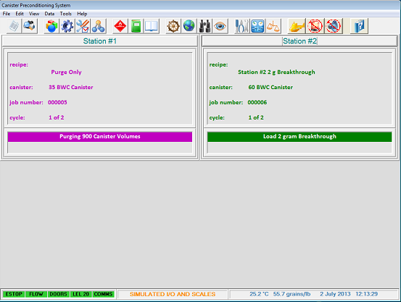

Canister Preconditioning System – Overview Screen

The user may use this screen to get a view of all stations’ current operational status.

Review Data Screen

Binoculars

Use this screen to check the recorded data of the current test while the test is still running. Use List of Jobs function to view the reports after the tests are complete. *Note:* the reports are only generated at the end of the tests.

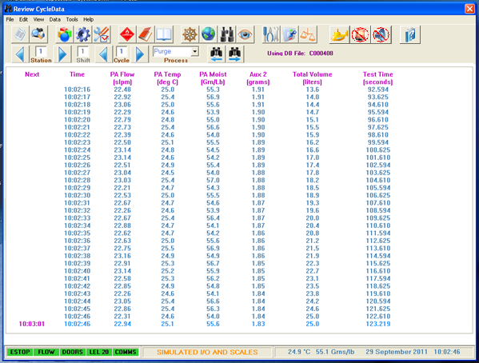

Review CycleData screen

Watch Data Screen

Eye

This screen is similar to the Review screen, however, it will show current and recent data for all active stations.

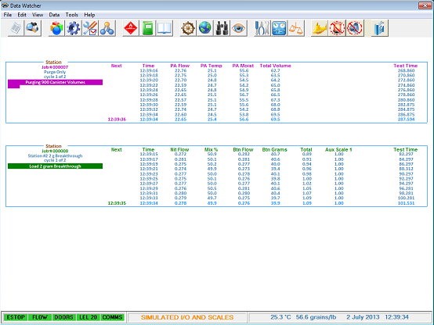

Data Watcher screen MFC Calibration Screen

Tools

This screen allows users to check and adjust the flow coefficients of the system mass flow controllers.

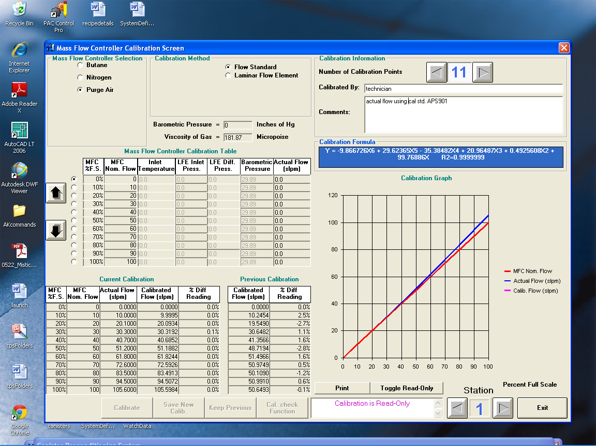

I/O Monitor Screen

Switch

The I/O Monitor screen allows the user to monitor and control (force) various system I/O items. This feature is very useful for troubleshooting the system, should the need arise. Caution must be exercised while using I/O forcing as control is taken away from the system’s computer. Depending on current password level, the I/O monitor may not be available.

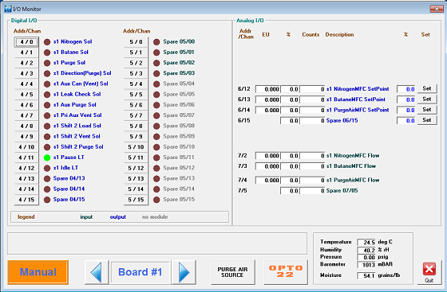

Scale Monitor Screen

Scales

This screen allows configuration and monitoring of scales used in the CPS system. Scale weights are updated in real-time.

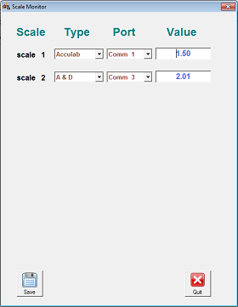

Turn Off Beacon

 Push to acknowledge alarm and turn off system beacon.

Silence Horn

 Push to silence alarm horn. New alarms will cause horn to sound again.

Help

 Push to launch operator’s manual (opens this document).

#### 5.0 Reports / Report Generation

The Reporting System automatically creates reports for each process that is performed. These reports include the Summary Report(Notepad), the Detail Report(Notepad) and a Microsoft Access® database detail file. If selected in Configuration, an MS Excel report is also generated at the conclusion of the test. Reports appear in the path:

C:\cps_R7\reports

###### Summary Report

The Summary Report is a short report, 2 pages for every one to two cycles, that including the Header, Recipe, Start and End Barometric Pressure, Purge and Load Summaries and Alarm and Out of Tolerance Information. The Purge and Load Summaries include Minimum, Average, Maximum and Target values observed for flow rates and ambient conditions, and the Total Flow for each cycle.

###### Detail Report

The Detail Report is a much larger report that contains the Header, Recipe, Purge and Load Detail Sections, and Alarm and Out of Tolerance Information. The Purge and Load Detail Sections include pertinent process data taken at intervals specified in the System Configuration file during both the Purge and Load Processes.

###### File Naming Format

The file names for both Reports and Database are automatically assigned by the System with the following criterion:

Report Files

File Type: **ASCII Text**

Format: **<field1><field2><field3>nnnnnn_type.RPT**

*Filename Description*

<field1><field2><field3> These 3 separate fields are defined by the JOB function in the Configuration Screen

nnnnnn 6-Character Sequence Number (automatically incremented by 1 for each new job)

type Either “Summary” or “Detail”

RPT 3-character File Extension

Database Files

File Type: **Microsoft Access Database**

Format: **Cnnnnnn.mdb**

*Filename Description*

C File Prefix

nnnnnn Same 6-character Sequence Number defined by the Report System

mdb Microsoft Access Database File Extension

###### Generating Reports

The Reporting System will automatically assign a new report filename and begin logging data for a station whenever a new test is activated by a user. The corresponding filename will be displayed on the upper right corner of the Station Detail screen for the duration of the process.

During the process, the reporting system logs data to a Microsoft Access Compatible Database file. The filename will be *Cnnnnnn.mdb.* Where nnnnnn is the sequence number of the process. Operational data and comments may be entered or changed on the Station Detail screen at any time while the process is active.

Upon completion of the process and before the station has been returned to the IDLE mode, the Summary, Detail and Access reports are generated using data from the Database File. If the System Configuration is set to automatically print either the Detail or Summary report or both, the reports will be printed at this time.

**Note: If the system was shut down due to a power failure or a software crash, it will be impossible for the system to generate reports for all incomplete processes. If the Job List entry for a particular test is lacking a Stop Time, report generation will fail.**

At the end of the Data section for the Summary and Detail reports, the system prints a Completion Status line. This line will read either *Job Completed Normally*, or *Job Completed Abnormally.* This line indicates whether the process ran without interruption to completion or whether it may have been stopped before being allowed to complete.

In a normal process, all cycles will be run and at the end of the process, the report will be generated and the station will enter the IDLE mode. In the event a user aborts in a middle of a process from the Detail screen, the system will still generate and then go into the IDLE mode.

*Job Completed Normally* indicates that the process was not aborted by the user.

*Job Completed Abnormally* indicates that the process was aborted by the user.

#### 

#### 6.0 Canister Weight Monitoring

There are two different methods for canister weight monitoring – Single Scale Method and Dual Scale Method. The Single Scale Method is only monitoring the weight gain on the auxiliary (secondary) canister while the Dual Scale Method is monitoring the weight gains on both (primary and auxiliary) canister. *Note:* Actual Canister Preconditioning System may not match the following illustration.

###### Single Scale with Stand Alone Canister Method

With this connection arrangement, the auxiliary canister is the only unit placed in the scale bay and the system is only monitoring the weight gain on the auxiliary canister.



###### 

###### Single Scale with Service Port Method

This method is for in-vehicle canister with connection via the service port. The system only monitors the auxiliary canister in the scale bay.



###### Dual Scale Method

With this connection arrangement, both primary and auxiliary canister units are placed inside their own scale bay separately and the system is monitoring the weight gain for both canisters.

###### `

LEAK CHECK

STATION #1

PAUSE

LOAD

PURGE

IDLE

SCL-1

IDLE

LEAK CHECK

PURGE

LOAD

PAUSE

STATION #2

SCL-2

SCL-3

PURGE

STATION #3

PAUSE

LOAD

LEAK CHECK

IDLE

AUX

PRIMARY

CANISTER

LOAD

VENT

PURGE

AUX

CANISTER

###### 7.0 Hot Keys

The Main Status Screen has active keys that bring up functions directly, some of which are not available from the menus. The Hot Keys and their associated functions are defined below:

ALT - L Logoff Current User

ALT - P Password Entry Screen

ALT - D Display Current Password and Access

(Must be in Password Entry Screen)

CTRL - ALT - SHIFT A Perform Password Access Maintenance

(Must be in main screen)

CTRL - ALT - SHIFT M Perform File Maintenance

#### 8.0 Spare Part List and Maintenance Schedule

Analytical Process Systems recommends the following spare part items and maintenance schedule:

###### Spare Parts

**Qty Designator Part# Description**

1 FIL1 21205 Filter, Monnier, 20 Micron

1 FIL2 21037 Filter, Monnier, 3 Micron

1 106HCT SNR 321 Gas Sensor, Hydrocarbon

###### Maintenance Schedule

**Annually**

Mass Flow Controllers – Calibrate in-situ using laboratory standard, or, remove and send out for calibration.

Scales – Clean and level if necessary, then calibrate with standard weight set.

Temperature/Humidity Transmitter – Verify readings against standard instrument or send out for calibration service.

Barometer – Verify readings against standard instrument or send out for calibration service.

Filter Elements – Replace compressed air and purge air elements. Change more frequently if needed.

**Semi-Annually**

HC Monitor(s) and Sensor(s) – Calibrate, test alarms, and replace element(s) as needed.

#### 9.0 Facility Requirements/ Specifications

Utilities: 120 VAC, 20 Amp, single phase AC Mains power, connected through disconnect.

Clean, dry compressed “shop” air, 90 PSIG delivery pressure., 2 SCFH

Compressed gases: pure nitrogen (purge air)., 99.5% Instrument Grade butane

Gasoline or other compatible testing fuel for live fuel vapor loading

***Specifications of major components***

Alicat mass flow controllers/meters, accuracy = +/-(0.8% reading + 0.2%F.S.) @STD conditions of 1 Atm, 20oC

Vaisala HM120 temperature/humidity meter, accuracy = 0.2oC/1.5%R.H.

Gems tank level transmitter, accuracy +/- 1% of 16 mA

Sartorius Signum 3 Laboratory Balance accuracy(linearity) = 1.5 grams

Setra Model 278 Barometer non-linearity = 0.4 hPa

#### 9.0 Legal

**Terms and Conditions of Sale**

The Customer agrees to register and license any software provided by APS from third party vendors as required by the developer or licensor. The customer agrees to accept the license terms that are construed to be accepted upon opening and/or use of the software media.

The Canister Preconditioning System computer as shipped has the automatic software update feature disabled. Please do not enable this feature in a network type environment. No server based broadcast type software updates should be carried out on this computer. This computer should not be used for any internet browsing or for downloading any software.

No games should be played on this computer during a test process as this may disrupt the time slicing feature in the software.

Virus check should be run at least once a month to check and eliminate any viruses on the system.

Before updating the APS application software, make a backup of the CPS_r5 directory. This will ensure that the calibration, process and recipe files are saved in a safe place and can be manually retrieved if required.

A copy of the Mass Flow controller calibrations should be saved on a removable media for safe-keeping.

Any system relocation or hardware modification will void the warranty on the system. Any service call to address any of the aforementioned items or issues will be billable at our applicable service rates.

Please call Analytical Process Systems, Inc. at (248) 393-0700 before loading or reloading any software on this system. APS will not be liable for any loss, damages, loss of income of any nature arising out of the use or inability to use this software or program, including, but not limited to claims, suits or causes of action.

### 

### Appendix A Out of Tolerance (OOT) Determination

The Reporting System provides out of tolerance (OOT) messages whenever the flow of Purge Air, Butane and Nitrogen, or the ambient temperature or moisture conditions are outside of tolerance specification. During the OOT event, the stations affected will go into the pause mode if selected by user in the System Configuration menu and require user input to either continue or abort the tests.

**Ambient Conditions**

Purge Air temperature and moisture levels are monitored only while a purge is in progress on the station.

An OOT event occurs when either value travels outside the desired range for the duration specified by OOT/MFC Delay variable. Each time an event occurs, an OOT message is written to the station reports indicating the time and the condition that occurred.

The temperature and moisture target values, tolerance limits, and the OOT/MFC Delay variables are specified in the System Configuration file.

**Flow**

The flow values for purge and load are ignored, during the initial time specified by MFC Settle Time variable in the System Definition file, to allow time for the Mass Flow Controllers to settle.

Once the settling time has expired, an OOT event occurs when the actual flow value travels outside the desired range for the duration specified by OOT/MFC Delay variable. Each time an event occurs, an OOT message is written to the station reports indicating the time and the condition that occurred.

The purge, butane and nitrogen target flow values are specified by the user in the Process Recipe file for each station.

The purge and load tolerance limit values, and the OOT/MFC Delay variables are specified in the System Configuration file.

### 

### Appendix B Summary Data Collection

The system completely reads all new data from the process approximately once every second. Approximately every 1/2 second the system checks the condition of each station and updates the Summary Data, which includes a running Maximum, Average and Minimum value for the Purge Air Flow, Purge Air Temperature, Purge Air Moisture, Butane Flow and Nitrogen Flow during the applicable Purge and Load Processes.

### 

### Appendix C Moisture Calculation

The Canister Preconditioning System uses the following equation for calculation of Absolute Humidity. This equation has been provided by a manufacturer of Humidity Sensors and has been verified with published tables throughout our anticipated range of operation.

G= 6.1366 * e( (18.678 - (Tc / 234.5)) * Tc / (Tc + 257.14 ))  * (HR / 100)

MA =0.007 * 622000 * G / (PB - G)

The result is in Grains / lb.

Tc = Temperature in Degrees Celsius

HR = Relative Humidity in % rH

MA = Absolute Moisture in Grains / Lb

PB = Barometric Pressure in millibars

The temperature and relative humidity values are derived from the General Eastern Dew Point monitor installed in the system. The Barometric Pressure is an analog input derived from the system Barometric Pressure Sensor or the building common Barometer.

The current Temperature and Absolute Moisture level, in Grains per Pound, is displayed on the Main Menu Screen. The current values of Temperature, Relative Humidity and Barometric Pressure are displayed on the I/O Monitor Screen.

***Analog Input Scaling***

The Purge Air Temperature signal from the temperature transmitter is a 4-20ma signal with a range of -20 to 140 degrees Fahrenheit.

The Relative Humidity signal from the humidity transmitter is a 4-20ma signal with a range of 0 to 100 % rH.

The Barometric Pressure signal is a 0 to 5 volt signal with a range from 600 to 1100 mBar. (27 - 32 in.Hg)

### 

### Appendix D Password Access Maintenance

Authorized users with the proper level of access may use the Password Access maintenance function to add or delete authorized users and change user access to system functions.

For users with the proper access level, pressing CTRL - ALT - SHIFT A simultaneously accesses the Password Access Control Screen. This screen displays each authorized user by user name and password along with that users access list.

The User Name and Password may be directly modified and changes take effect immediately.

The Access List defines which features that user has access to. It is a string of characters, with each character, or access key, identifying a particular reporting system function or group of similar functions. The user has access to any functions with an access key present, the user is denied access to any functions for which the access key is not present.

The Access String may be directly edited with changes taking effect immediately.

Any user may also be deleted by highlighting the record line and pressing the DELETE key. The record line is highlighted by clicking on the tab at the left side of the record.

At “Password Control Screen”

ALT- D Displays current password

The following list details the access key assignments for the system. Access keys are case sensitive.

**Access Key Functions Allowed**

|  |  |
| --- | --- |
| A | File Menu |
| B | Edit menu |
| C | View Menu |
| D | About Menu |
| E | File Copy Menu |
| F | File Print Menu |
| G | File Exit Program |
| H | Access System Configuration |
| I | unused |
| J | Access Password Access Screen |
| K | View Station Detail Screen |
| L | View File Log |
| M | View Job List |
| N | View Process and Canister Recipes |
| O | Load/Save System Configuration File and Process Recipes |
| P | Load/Save Canister Recipes |
| Q | Change Station Detail Text |
| R | Start/Stop Station |
| S | Data Log Clear |
| T | Job Log Clear |
| U | Thermocouple On / Off on Station Detail |
| V | Allow Manual File Maintenance |
| W | Printer Font Select Test Screen Button |
| X | Calibration Screen Access |
| Y | unused |
| Z | Error Log Access |
| 0 | Change Debug Flags, IO Com On, etc. on Sys. Def. Screen |
| 1 | Change File Name / Prefix in System Configuration |
| 2 | Access Com I/O Forcing Screen |
| 3 | unused |
| 4 | unused |
| 5 | Password Maintenance Screen |
| 6 | Access Scale Monitor Screen |
| 7 | unused |
| 8 | unused |
| 9 | unused |

### 

### Appendix E Terminology

**Recipe Number**

Identifies the default recipe on the CPS. Up to 99 default recipes may be saved.

The recipe number displayed on station recipe screen represents the default recipe used to start the process. The recipe may have been modified by the user prior to starting the process.

**Number of Purge / Fill Cycles**

Specifies the number of Purge and Fill Cycles that will be performed on the canister under test.

**Purge Flow Rate**

Flow rate for the purge air, in standard liters per minute units.

**Canister Volumes**

Determines the volume of purge air flowed during the purge process. The total air volume is equal to the number of volumes times the specified volume of the canister.

**Load Flow Rate**

The flow rate of butane used during the Loading Process. The flow rate is specified in grams per hour.

**Percent Butane**

The Loading Process is performed by flowing a mixture of butane and nitrogen into the canister. This value specifies the % of the mixture that is butane. The nitrogen flow rate is determined using the Percent Butane and the Butane Flow rate.

**Load Time**

Load Time, specified in minutes, may be used as an alternate to the Working Capacity Multiplier or Scale Breakthrough method to determine the duration of the Loading Process. When Load Time is used, the canister is loaded for the period specified using the Butane Flow Rate and Percent Butane to determine the load mixture, or with the use of live fuel vapor.

**Working Capacity Multiplier**

The Working Capacity Multiplier may be used to specify the Loading Method. When used, the canister is Loaded with a volume of Butane or fuel vapor equal to the product of the Working Capacity Multiplier times the Canister Working Capacity.

**Breakthrough / Load Target Weight**

This value may be used to determine the Loading Method. The scale is required when this value is used.

When the Primary Canister is placed on the scale, the process will load until the target weight is achieved on the Primary Canister.

When the Auxiliary Canister is placed on the scale, the process will load until the Primary Canister achieves *breakthrough*, and the Auxiliary Canister achieves a weight gain equal to the value specified in this field.

**Purge Process**

The process of purging the evaporative canister with ambient air prior to the Loading Process. Purging the canister removes butane or fuel vapor from the canister.

**Breakthrough**

A term used to describe the point during the loading of a canister when the canister becomes saturated with vapor and no longer absorbs all of the vapor flowed through it. The Breakthrough Point is typically the point when an Auxiliary Canister connected to the vent port of the Primary Canister will have absorbed 2 grams of vapor not absorbed by the Primary Canister.

**Auxiliary Canister**

When performing a Load to Breakthrough, a second canister is placed in series after the Primary Canister. The vent line from the primary canister is connected to the load line of the auxiliary canister. Vapors not absorbed by the primary canister are captured in the auxiliary canister. The auxiliary canister weight gain is used to determine the breakthrough point and working capacity of the primary canister.

**Primary Canister**

The canister being purged or loaded by the system.

**Canister Working Capacity**

The amount of butane or fuel vapor that a canister will absorb when loaded to breakthrough. The Working Capacity is typically determined by loading a canister with either fuel vapor, or a 50% mixture of butane and nitrogen at a load rate determined by the operator, until an auxiliary canister in series with the primary canister achieves a weight gain of 2 grams. The nominal working capacity is the average working capacity of five sample canisters, determined in the above manner.